**Data Science news Estimator:**

* Created a tool that estimates news which fake or real

**Packages:** pandas, numpy, sklearn, matplotlib, seaborn.

**The solving mechanism**

* build machine learning model using python

**Describe the dataset**

* Data source:
  + https://drive.google.com/file/d/1er9NJTLUA3qnRuyhfzuN0XUsoIC4a-_q/view
* Data description
* I use pandas library to description dataset
  + df.info()

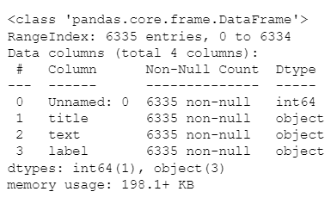

* + number of rows (6335) and num of columns (4)
  + name of columns and data type for each column
  + their no null values in columns
  + ensure that the dataset is clean

**descriptive statistics and data distribution charts**

I looked at the distributions of the data and the value counts for the various categorical variables. Below are a few highlights from the pivot tables.

|  |  |
| --- | --- |
| Label | Count |
| FAKE | 2410 |
| REAL | 3171 |

**TABLE 1**

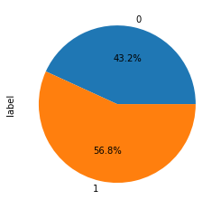

**Figure 1**

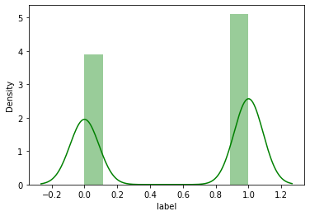

**Figure 2**

**Table 1**

**Figure 5**

**Comment**

* (Table 1 ) pivot_table explain counts of fake and real news
* (figure 1) pie explain percentage of REAL (1) and FAKE (0) news.
* (figure 2 ) distplot explain distribution of data in dataset

**Model Building**

First, I split data to X and Y

I also split the X ,Y into train and tests sets with a test size of 20%.

And I apply **TfidfVectorizer** to make transform the X to help us to use it in training and predict

I tried model:

**Passive Aggressive Classifier**–Belongs to the category of online learning algorithms in machine learning. It works by responding as passive for correct classifications and responding as aggressive for any miscalculation

* **Model performance**

The Passive Aggressive Classifier model get performance high.

**Passive Aggressive Classifier**: = 93.05%